 | Incident  Report Form |  |  |  |  |  |  |  | Tick the box which applies  This form is reporting …  ¨ Accident ¨ Incident  ¨ Near Miss ¨ Injury  ¨ Illness ¨ Death  ¨ Harassment, abuse or other psycho emotional harm  ¨ Other personal health concern or event  ¨ Damage to equipment or property
 | PERSONAL DETAILS OF PERSON INVOLVED IN INCIDENT
 | First Name |  |  |  |  | Last Name |  |  |  |  |  |  |  |  | Date of Birth
 | Home Phone |  |  | Work Phone |  |  |  | Cell Phone |  |  |  |  |  | E Mail
 | Home Address
 | RIDE DETAILS
 | Group Name or Description |  |  |  |  |  |  |  |  |  |  | Description of Route (incl. intended time, distance)
 | Ride Leader Name |  |  |  |  |  |  |  |  |  |  | Ride Leader Phone
 | Description of Weather Conditions |  |  |  |  |  |  |  |  |  |  | Description of Road/Route Conditions
 | DETAILS OF THE EVENT OR PROBLEM Please fill in the spaces which apply
 | Date |  |  | Time |  |  |  | Time into ride when incident occurred
 | Location / Address
 | Description (describe what happened and continue on the back of the page if necessary)
 | What was occurring at, or around, the time this event happened or problem became apparent?
 | What do you think caused this? (Also describe any contributing causes i.e. something unusual that may have lead to this event, or occurred at the time)
 | Describe any property damage (if applicable)
 | DESCRIPTION OF THE INJURY OR HEALTH ISSUE Please tick the boxes and mark the areas which apply
 | Type of Complaint  (Tick more than one box if required |  |  |  | Location of Injury or Complaint  (Mark the location of injury on the outline below) |  |  |  |  |  |  |  |  |  |  |  | Action Taken  (Tick more than one box if required)
 | ¨ No injury  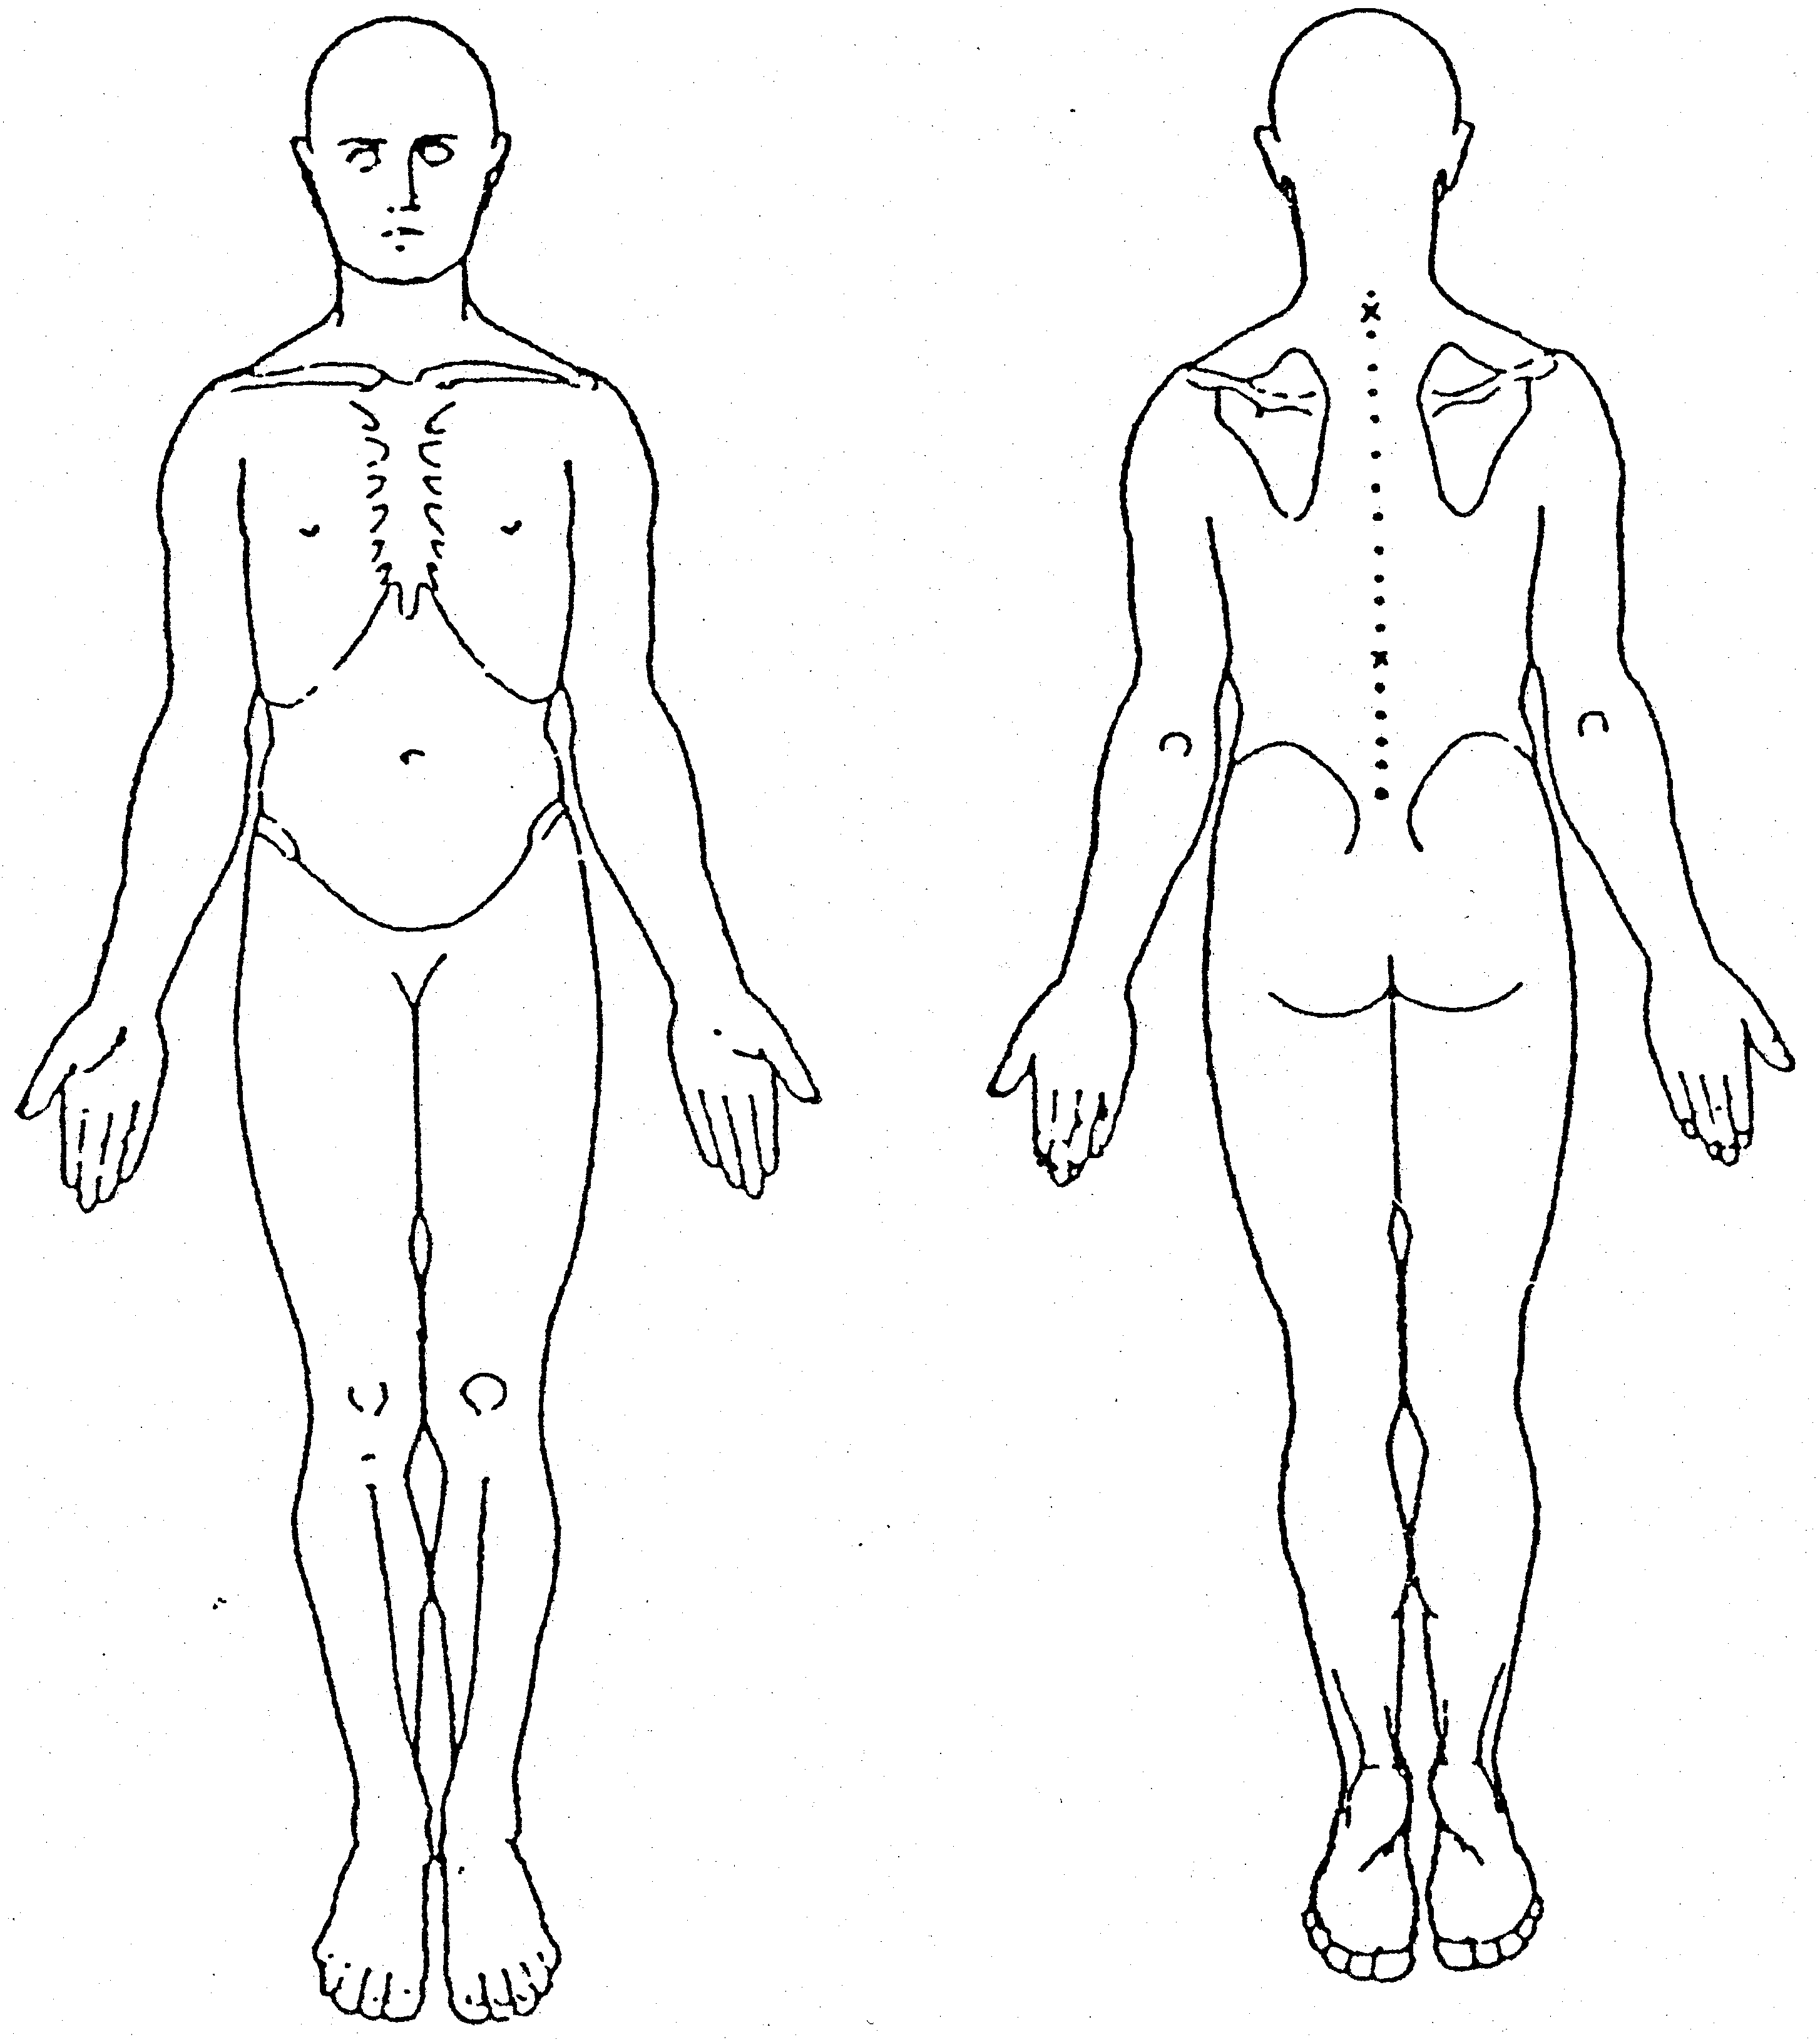  ¨ Abrasions  ¨ Amputation  ¨ Animal bite  ¨ Bleeding  ¨ Breathing difficulty  ¨ Broken bone  ¨ Bruise  ¨ Burn  ¨ Concussion  ¨ Cut  ¨ Discomfort  ¨ Dislocation  ¨ Electric Shock  ¨ Faint  ¨ Headache  ¨ Infection  ¨ Nose bleed |  | ¨ Pain  ¨ Sprain  ¨ Sting (insect)  ¨ Strain/Sprain  ¨ Swelling  ¨ Tingling  ¨ Numbness  ¨ Feelings of  anxiety  ¨ Tiredness  ¨ Fatigue  ¨ Other (describe) |  | 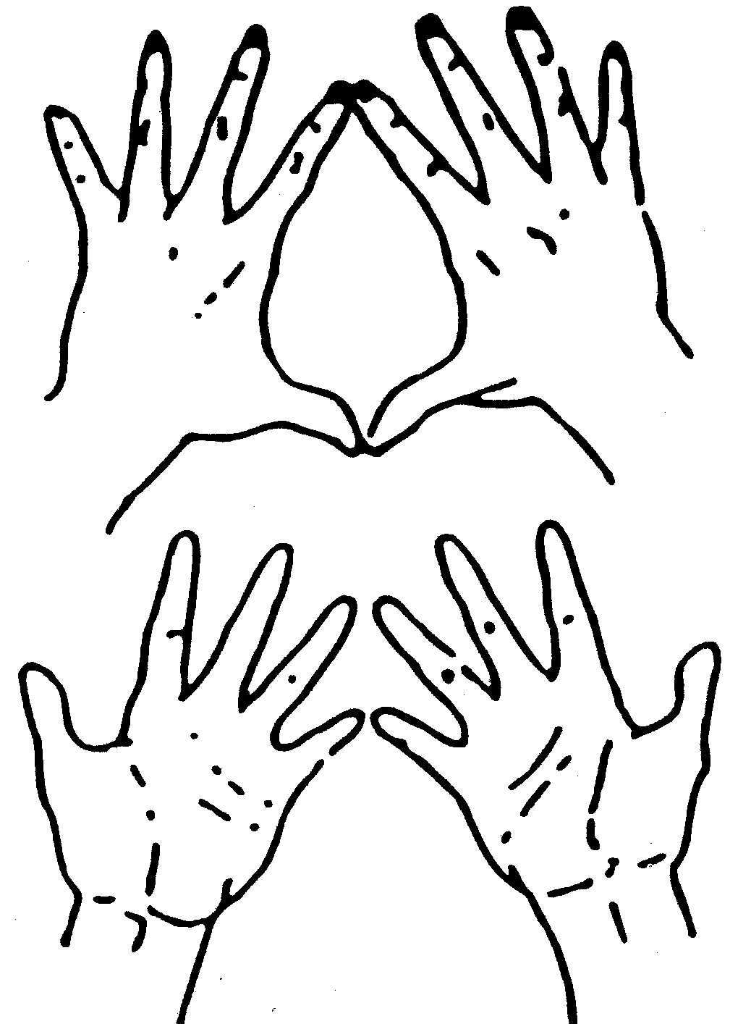 |  |  |  |  |  |  |  |  |  |  |  | ¨ None as yet  ¨ First Aid  ¨ Acupuncture  ¨ Ambulance  ¨ Chiropractor  ¨ Counsellor  ¨ De-brief (informal)  ¨ Family Doctor  ¨ Hospital  ¨ Massage  ¨ Osteopath  ¨ Physiotherapy  ¨ Private A&E Clinic  ¨ Psychologist/Psychiatrist  ¨ Workplace support referral  ¨ Other (describe)
 | FORM COMPLETED BY
 | Name |  |  |  |  |  |  |  |  | Signature |  |  |  |  |  |  |  |  | Date ___/___/___
 | Please give this form to your designated leader on the day that this event or problem occurred or became apparent
 | Designated Leader – Refer to the Investigation Form Overleaf
 |  | Investigation Form
Further Background Details
List below names and contact details of witnesses and/or any others involved in the event
Causes Identified
Immediate Causes - What actions and/or conditions caused or could have contributed to this event?
Contributing Actions Identified |  |  |  |  |  |  |  |  |  |  | Contributing Conditions Identified
Basic Causes – What specific personal or ride-related factors caused or could have contributed to this event?
Personal Factors Identified |  |  |  |  |  |  |  |  |  |  | Ride-related Factors Identified
Description of Causes and/or Circumstances Identified (if required)
Preventative Action Plan What action has or will be taken to prevent a recurrence?
Action |  |  |  |  |  |  |  |  |  |  |  |  |  |  |  | By Whom |  |  |  |  | By When
Authorities Informed
Name of Authority |  |  |  |  |  |  | By Whom |  |  |  |  |  | When |  |  |  |  | Reference (if any)
Names of Investigators |  |  |  |  |  |  |  |  |  |  |  |  |  |  |  |  |  |  |  | Date of Investigation

